 **DHA SUFFA UNIVERSITY**

**Department of Computer Science**

**Course Title: Human-Computer Interaction.**

**Section: BS-SE-3B,**

**Submission Date: 23-Jan-23**

*Group#03*

***Team Members:***

* Zeeshan Javed (se-211067)
* Muhammad Hanzalah (se-211090)
* Huzaifa Khalid (se-211102)

Human Computer Interaction Project Report

OF

Our Team Website: Yale School of Art

*Link:* <https://www.art.yale.edu/>

Requirement Gathering

|  |  |
| --- | --- |
| Developer | Zeeshan Javed (SE-211067) |
| Clients | Huzaifa Khalid (SE-211102)  Muhammad Hanzalah (SE-211090) |

Contents

* Introduction
* Scope
* Review
* Analysis
* Evaluation
  + User based
  + Psychological based
  + Laboratory based
* Conclusion

Introduction:

The **Yale School of Art** is the art school of Yale University. Founded in 1869 as the first professional fine arts school in the United States, it grants Masters of Fine Arts degrees to students completing a two-year course in graphic design, painting/printmaking, photography, or sculpture.

Scope:

Artists and designers of unusual promise and strong motivation are provided an educational context in which they can explore the potential of their own talents in the midst of an intense critical dialogue. This dialogue is generated by their peers, by distinguished visitors, and by a faculty comprised of professional artists of acknowledged accomplishment.

The graduate students primary educational experience at Yale is centered on the students own studio activity. Supporting this enterprise are the experience, knowledge, and skills gained from rigorous, structured courses such as drawing, filmmaking, the relativity of color, and the rich academic offerings found throughout Yale. Each student is routinely exposed to many aesthetic positions through encounters with faculty members and visitors. The School is devoted not only to the refinement of visual skills, but also to the cultivation of the mind. Students must bring creative force and imagination to their own development, for these qualities cannot be taught—they can only be stimulated and appreciated.

The School of Art offers an undergraduate art major for students in Yale College (see the bulletin Yale College Programs of Study). In addition, the School courses are open to students in the Graduate School of Arts and Sciences and other professional schools of the University, and School of Art students may enroll in elective courses in the Graduate School and other professional schools as well as in the College with permission.

Review:

**Yale School of Art VS Institute of Fine Arts**

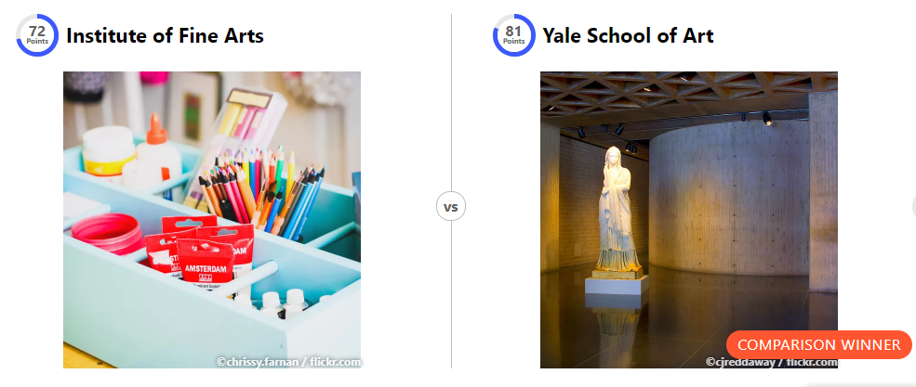

**Q: Why is Yale School of Art better than Institute of Fine Arts?**

**Ans:**

103 more academic staff?

144 vs 41

1% more international full-time students?

18% vs 17%

12 170.00$ bigger amount of funding available per student for one academic year?

38 170.00 $ vs26 000.00$

92.09% lower student to staff ratio?

0.87:1 vs 11:1

99 more years since its establishment?

1832 vs 1931

38 more post-graduate students?

126 vs 88

166787 bigger alumni network?

168987vs2200

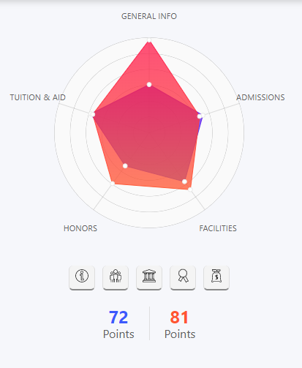

**Yale School of Art VS Tisch School**

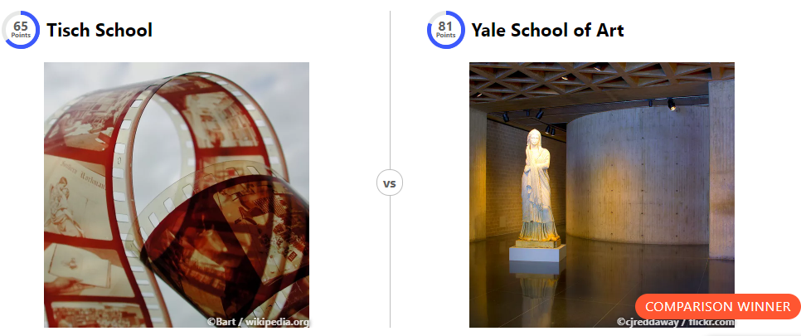

**Q: Why is Yale School of Art better than Tisch School?**

**Ans:**

14 061.00$ lower tuition required?

33 500.00$ vs 47 561.00$

14 061.00$ lower tuition required from international full-time students?

33 500.00$ vs 47 561.00$

1% more international full-time students?

18% vs 17%

12 170.00$ bigger amount of funding available per student for one academic year?

38 170.00$ vs 26 000.00$

90.34% lower student to staff ratio?

0.87:1 vs 9.01:1

133 more years since its establishment?

1832 vs 1965

17.97$ billion bigger amount of endowment obtained?

20.8$ billionvs2.83$ billion

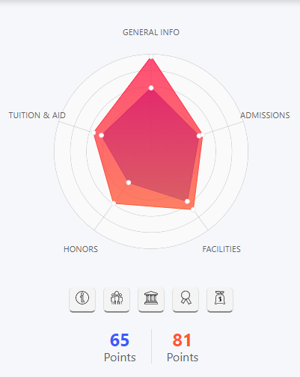

**Yale School VS Harvard School**

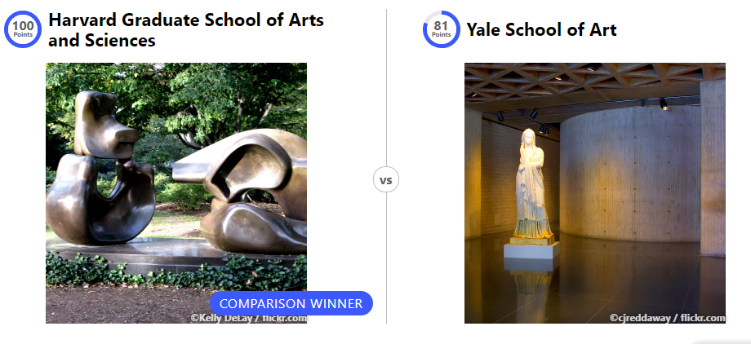

**Q: Why is Harvard Graduate School of Arts and Sciences better than Yale School of Art?**

**Ans:**

1963 more academic staff?

2107 vs 144

16% more international full-time students?

34% vs 18%

4034 more enrolled students?

4160 vs 126

8063 higher dormitory capacity?

13815 vs 5752

4034 more post-graduate students?

4160 vs 126

154013 bigger alumni network?

323000 vs 168987

0.56% lower crime rate in campus?

1.55% vs 2.11%

11.2$ billion bigger amount of endowment obtained?

32$ billion vs 20.8$ billion

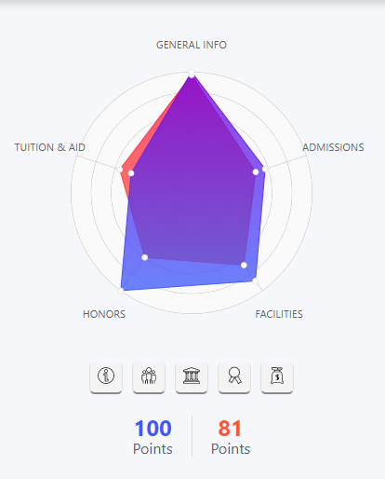



Analysis:

**Original Website VS Our Team Website**

**Original Website:**

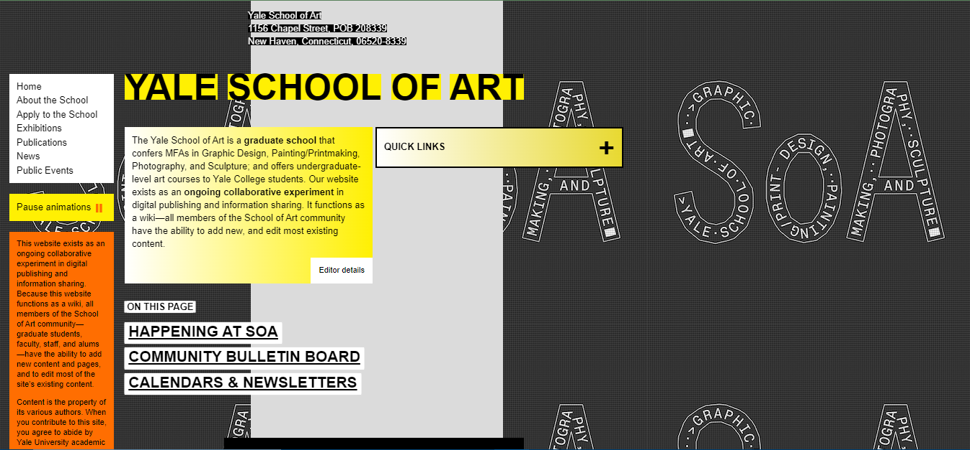

**Our Team Website**

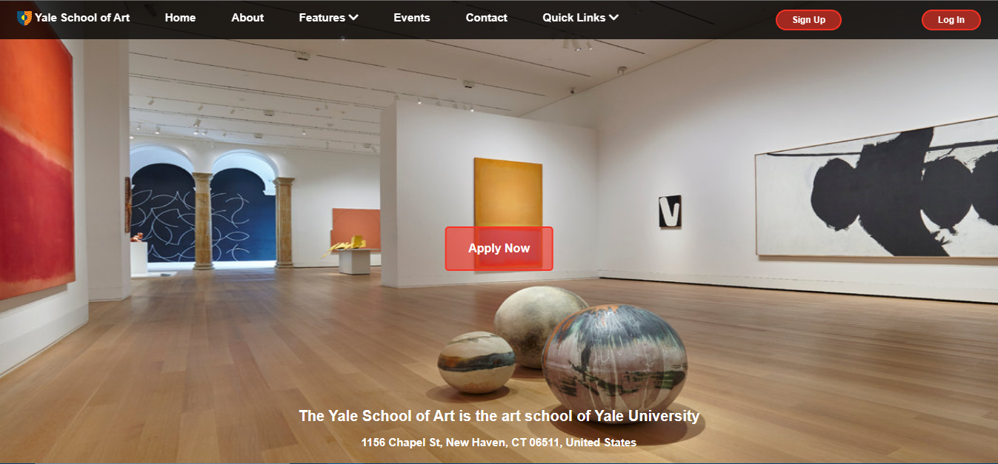

**Our Team Website Interactive Pie Chart:**

Evaluation:

**User Based: (Survey Questionaries)**

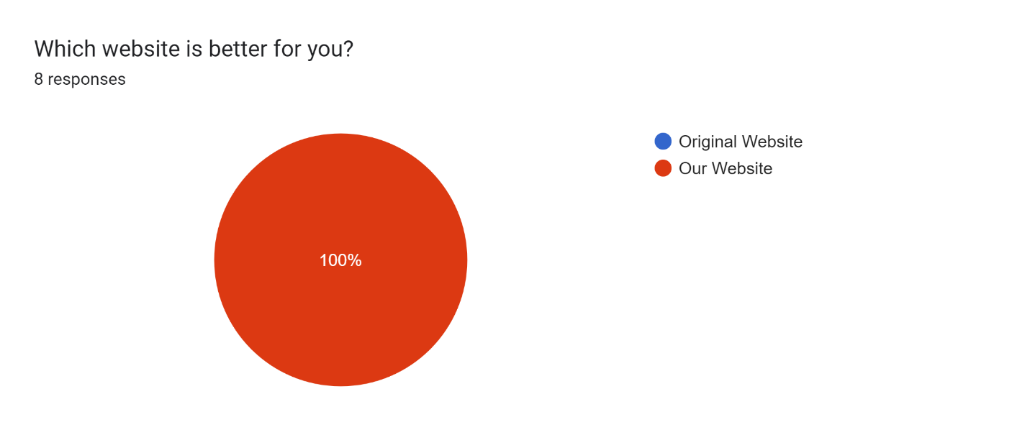

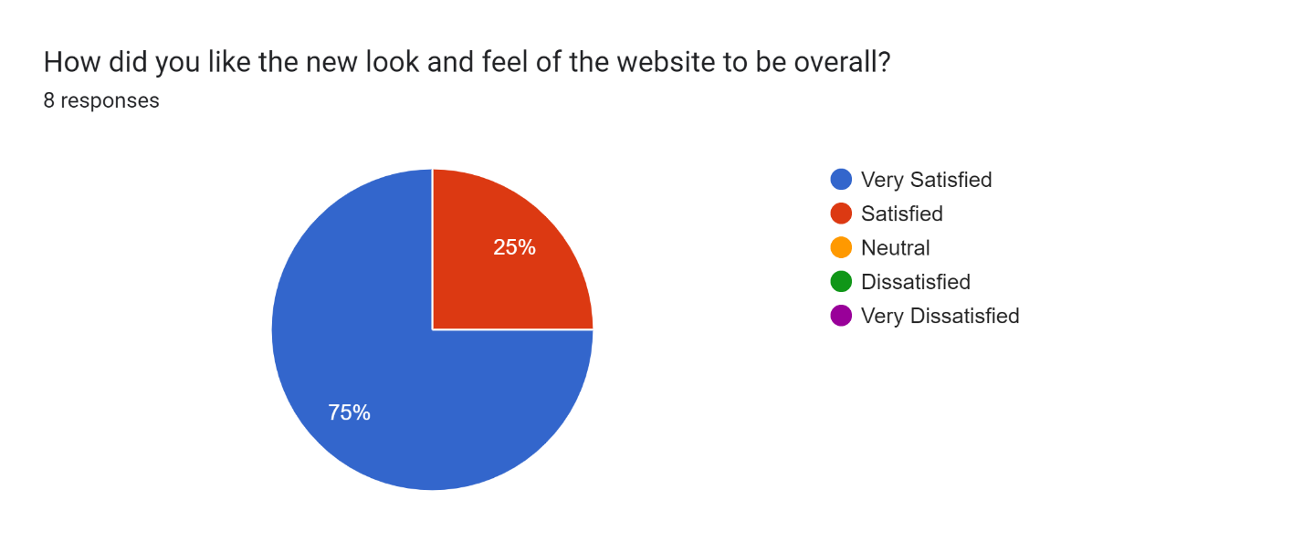

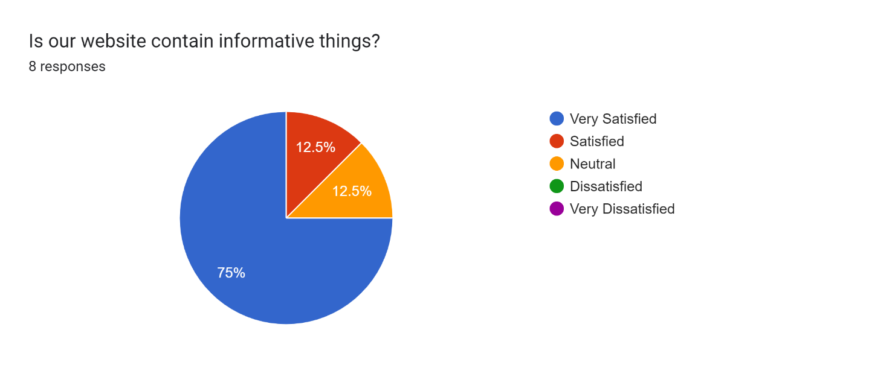

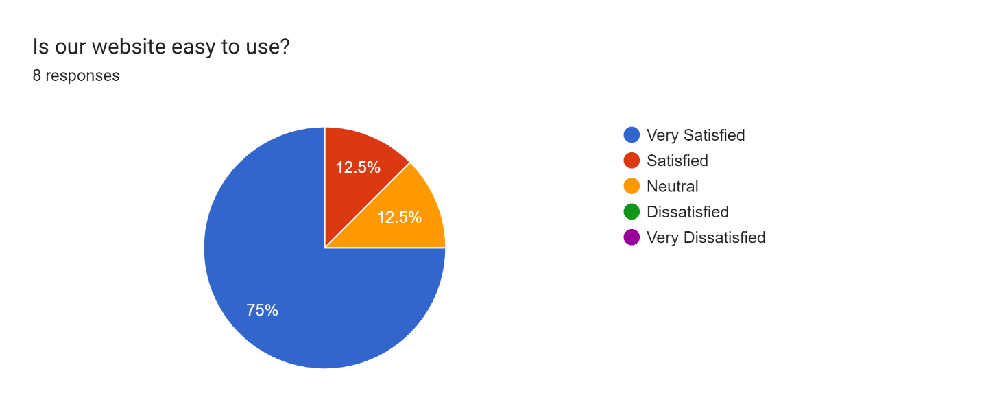

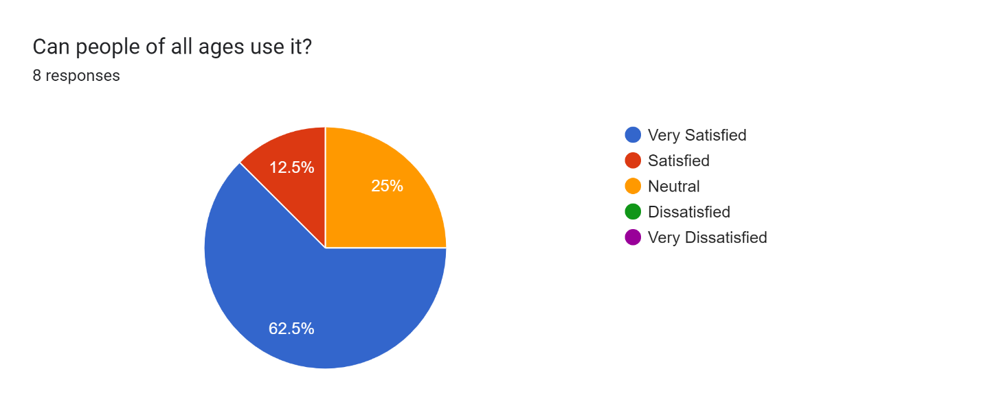

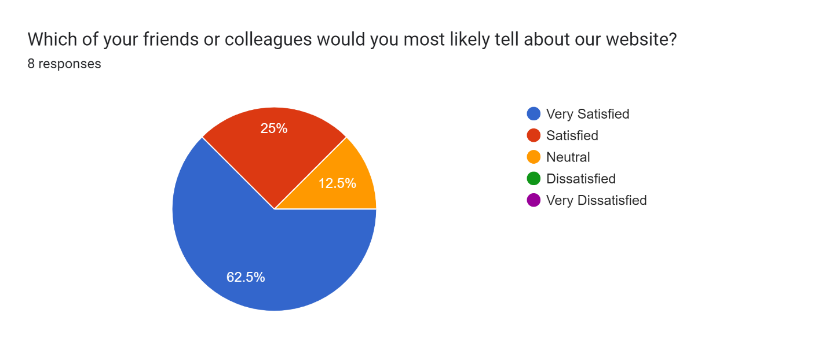

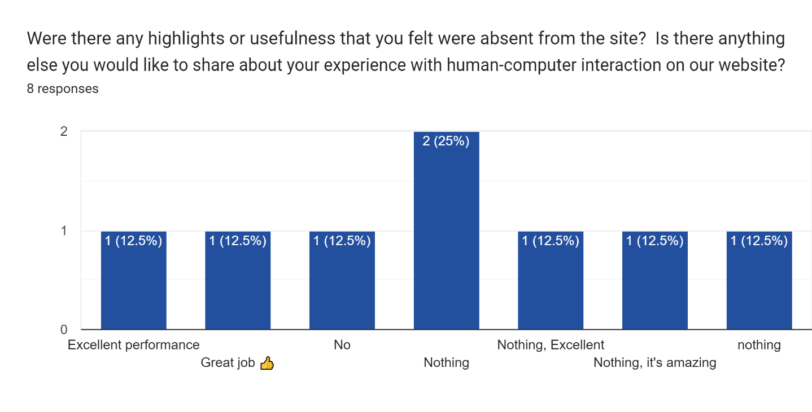

**Psychological Based:**

**Original Quick Links:**

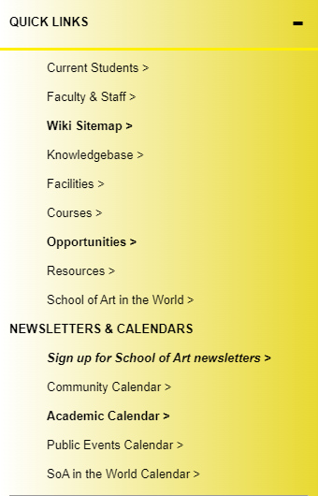

**Our Team Website Quick Links:**



**Original Calendar Section:**

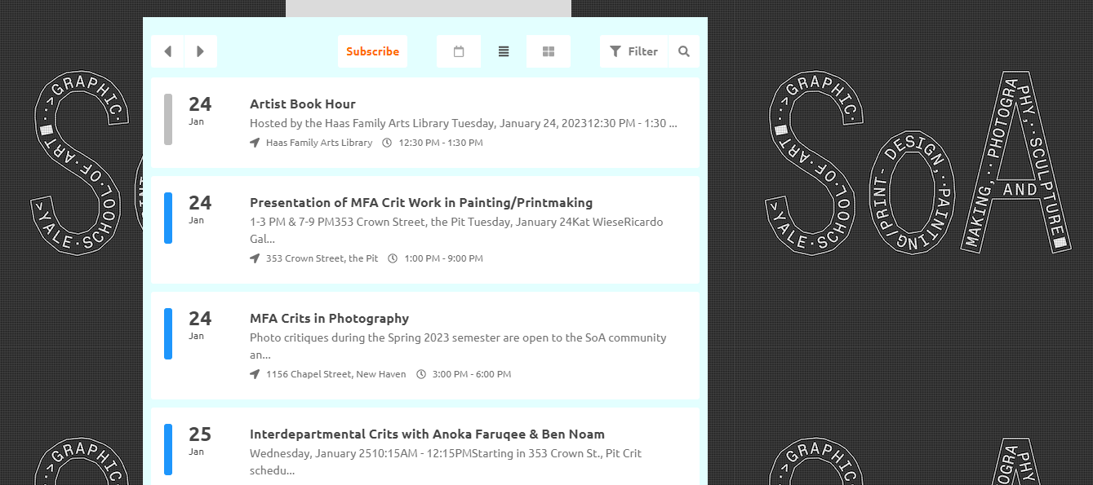

**Our Team Website Calendar Section:**

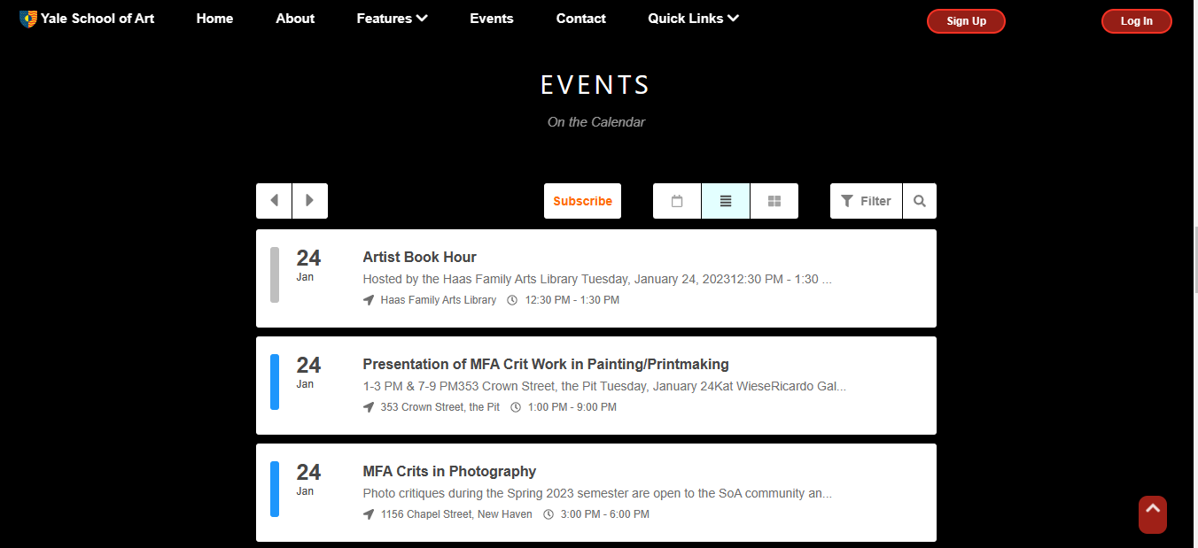

**Original Website Newsletter:**

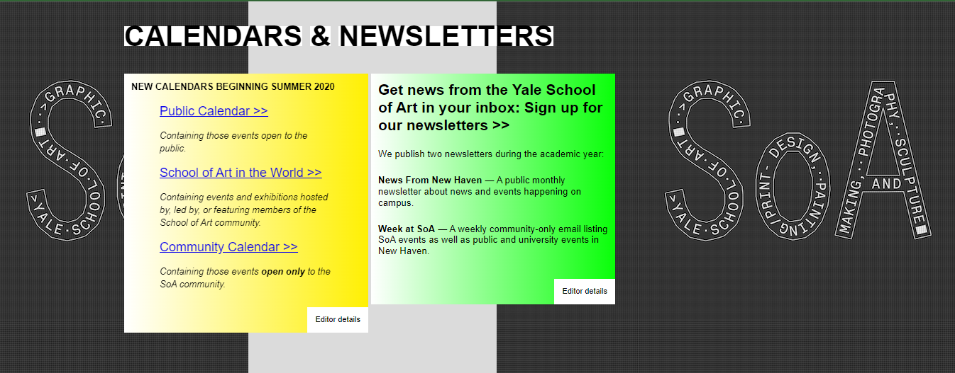

**Our Team Website Newsletter:**



**Original Website Footer:**



**Our Team Website Footer:**



**Original Website Navbar:**



**Our Team Website Navbar:**

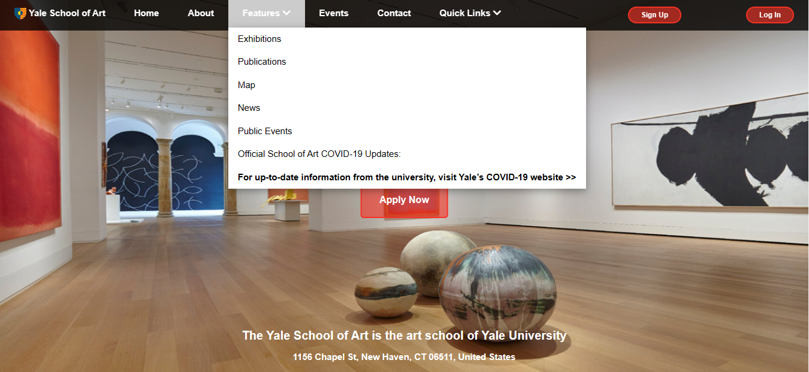

**Original Website Map and Bottom to Top Button:**

**Not included both of them**

**Our Team Website Map and Bottom to Top Button:**



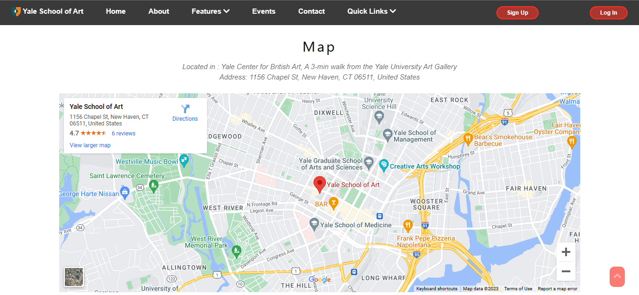

**Original Website Contact:**



**Our Team Website Contact:**

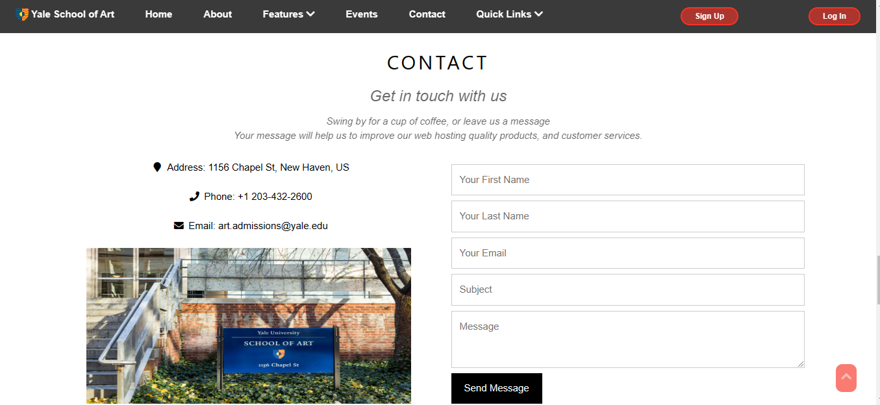

**Laboratory Based:**

**Original Website Report:**

Social: --------------------------->Yes (96%)

Mobile Friendly: -------------->Yes (100%)

Video: --------------------------->Not detected

Images: -------------------------> Optimized

Amount of Content: --------> 5,028 words on 5 pages

Local: --------------------------->Yes (97%)

Website build: ---------------->Yes (88%)

Organic Search: --------------> Yes (94%)

**Search terms:**

**(yale, yale university, henry winkler, confidence interval, dyslexia)**

Paid Search: ------------------->Found (100%)

**Paid keywords:**

**(project management certification, online business courses, international businesses, project management courses, business intelligence course)**

Conclusion:

Overall, the Yale School of Art website appears to be unstructured and difficult to navigate. The layout is not clear and not organized, and it is very difficult to find information on the various programs and resources offered by the school.

In this case our team changed this website into a better website and our website appears to be structured and easy to navigate as well as the layout is very clear and organized and also our website help us to find information on the various programs and resources offered by the school.

So, our team learned this project i.e. Human-computer interaction (HCI) is a crucial area of study in the field of computer science and engineering, as it deals with the design and development of computer systems that are easy to use and understand for human users. The ultimate goal of HCI is to create systems that are intuitive, efficient, and satisfying for users, and that can improve the quality of their interactions with technology. Overall, HCI is an interdisciplinary field that draws on concepts and methods from computer science, psychology, sociology, and other fields to create effective and user-centered systems.